Welcome to JU!
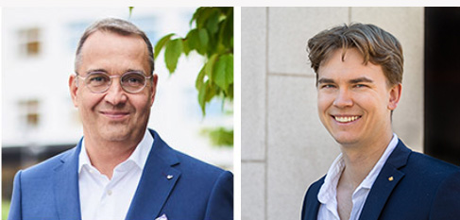
Måns Svensson, President at JU, and Alexander Metze, President of Jönköping Student Union, join together to welcome all students, old and new, to JU.
Dear JU student,
Welcome to Jönköping University, or JU as we usually abbreviate it. We hope that you will have a fun, rewarding, and stimulating time here with us. First and foremost, you are here to gain new knowledge and skills that you will carry with you in your future career, while you will also make new friends and discover the excitement of student life.
JU is characterized by internationalization, sustainability, entrepreneurial spirit and close collaboration with society. We are one of Sweden's most international universities, with approximately 16,000 students from 100 countries. Almost all our study programmes offer some form of internship that prepares you for professional life.
To help you get to grips with all aspects of your new life as a student, we offer an introduction with all the information you need. The introduction is divided into two parts, one academic and one social. The academic introduction gives you information about JU, about studying here and about the support you can get. The social introduction is organized by Jönköping Student Union, and it offers many different activities where you get to know other students.
The first activity is the Kick Off during weeks 35–36 and we hope that as many as possible take the opportunity to attend! It is a good opportunity to get to know fellow students, students from the other schools, our university and the city of Jönköping. We hope and believe there are activities for everyone, and all students are warmly welcome to all activities that take place in a safe and organized way. Respect and consideration are key words for us, and we have a Code of Conduct that defines how we are expected to treat each other.
Please read our Code of Conduct here
JU and the Student Union work together to ensure that everyone feels safe here and that we have fun together.
Once again, a warm welcome to JU and good luck with your studies! You have a fun and exciting time ahead of you!
Best regards,
Måns Svensson, President at JU, and
Alexander Metze, President of Jönköping Student Union
Link to Jönköping Student Union

